**Course: Advanced Bioinformatics**

**Module title: Knowledge discovery**

**Module no. : 178**

**Knowledge Discovery**

Knowledge discovery is largely data-driven, starting with the many existing large-scale data collections such as EHRs.

**Knowledge Discovery and Data Mining**

Knowledge discovery developed out of the data mining domain, and is closely related to it both in terms of methodology and terminology. It is well-known branch of data mining.

**Knowledge Discovery Usage**

The knowledge obtained through the process may become additional data that can be used for further usage and discovery.

**Knowledge Discovery Steps**

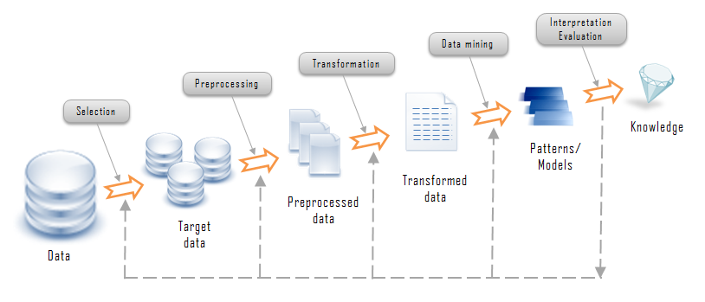

**Data Mining**

Data mining, is also referred to as knowledge discovery from data, is a multidisciplinary field.

The concepts and techniques used in data mining are a convergence of

* Machine Learning(ML) and Artificial Intelligence (AI)
* Database systems and statistics